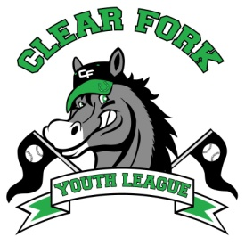
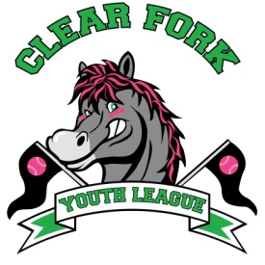
BOARD MEETING
MARCH 13, 2019
Attendance:
Jay Vail
Mike Hoeflich
Josh Smith
Carrie Knight
Allen Leech
Ashley Ludwig
David Myers
Lindsay Roberts

- Jay
  - To Baseball coaches
    - Went over coaching assignments, rule changes, skills and drills, draft, and field day
      - Team draft will be done by skill level
      - Practice times will also be drafted
- David
  - Needs to place an order for umpire safety gear
  - Batting cage is damaged, not sure if it is worth fixing, talked about possibly just making it work for this year until we can replace it with a new one
- Jay
  - Field maintenance position
    - Voted to hire Andy Kehl
      - One year contract, 10 weeks (April 29 – July 4) $300/week
    - Jay will meet with him to go over details of his responsibilities
  - Mowing
    - Signed contract with Sharp Lawns & Landscapes
  - Dugouts on Field 1
    - Will make some repairs and adjustments for the Unstoppables for this year with hopes of regaining field 4 by next year which will be their main field
  - Will get quotes on fixing the 3 wheeler
- Josh
  - Middle school softball update
    - Received Jr. High Softball registrations, with all of the expenses we will profit very little
    - Will revamp the whole thing after the season for next year
- Ashley
  - We had a request that there be a family cap for registration costs
    - Voted to cap at $180 per family
- Next Board Meeting April 10, 2019 7:00 @ Brumby’s

